# ***TOPIC: SIMPLE INVENTORY MANAGEMENT***

**AIM:**

The aim of this is project is to create **Simple Inventory Management System** using Python program

**OBJECTIVE:**

Inventory management is the supervision of non-capitalized assets (inventory) and stock items.

A component of [supply chain management](https://searcherp.techtarget.com/definition/supply-chain-management-SCM), inventory management supervises the flow of goods from manufacturers to warehouses and from these facilities to point of sale. A key function of inventory management is to keep a detailed record of each new or returned product as it enters or leaves a warehouse or point of sale.

In inventory management, goods are delivered into the receiving area of a warehouse in the form of raw materials or components and are put into stock areas or shelves.

Inventory management uses a variety of data to keep track of the goods as they move through the process, including lot numbers, serial numbers, cost of goods, quantity of goods and the dates when they move through the process.

**PROBLEM STATEMENT:**

Inventory management is the system of overseeing and organizing goods or materials. At its core, inventory management requires the monitoring of receiving, systematically storing, and locating of product. Inventory management is a careful balancing act of a multitude of factors, including: monitoring what you already have, what’s needed, already ordered, and being returned, or other factors like items on hold or in need of service.

The two basic inventory decisions that managers face are:

* How much additional inventory to order or produce
* When to order or produce it

**BLOCK DIAGRAM :**

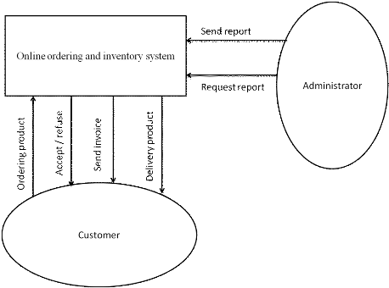

**PROJECT DESCRIPTION:**

The main function of this project is as follows

* Counting the stocks
* Controlling supply and demand
* Keeping accurate records

**DETAILS OF SOFTWARE:**

The programming language for the Inventory Management System application will be in PYTHON architecture will be used.

The program has been performed and executed on windows.

**CODE:**

file = open("inventory.txt", 'r+')

lines = file.readlines()

while(True):

choice = int(input("\n 1.Buy item \n 2.View Item \n 3.Exit\n "))

if choice == 1:

print("Item \t price \t available count")

items = []

for line in lines:

item, price, count = line.split(',')

print( item, "\t", price, "\t", count)

items.append(item)

print("which item you want to buy:", items)

item_choice = input()

if item_choice == input():

print("item is not available\n")

break

else:

for l in range(len(lines)):

if lines[l].split(',')[0] == item_choice:

item, price, count = lines[l].split(',')

count = int(count)-1

lines[l] = ','.join([item, price, str(count) + '\n'])

print("thanks for buying")

elif choice == 2:

print("items\tprice\tavailablecount")

for line in lines:

item, price, count = line.split(',')

print(item, " \t ", price, " \t ", count)

else:

file.seek(0)

for lin in lines:

file.write(line)

file.close()

break

**SCREEN SHOTS :**

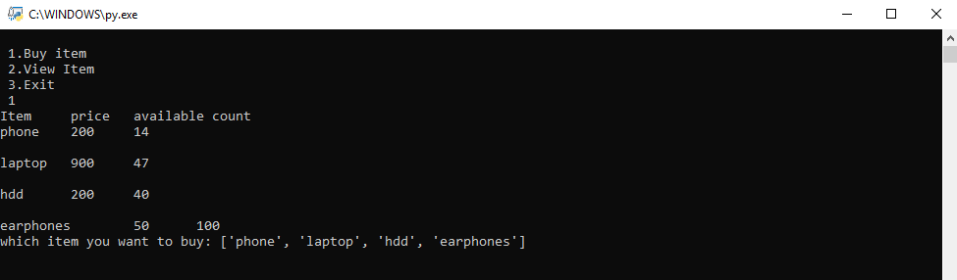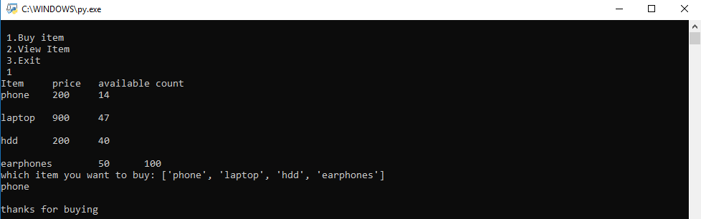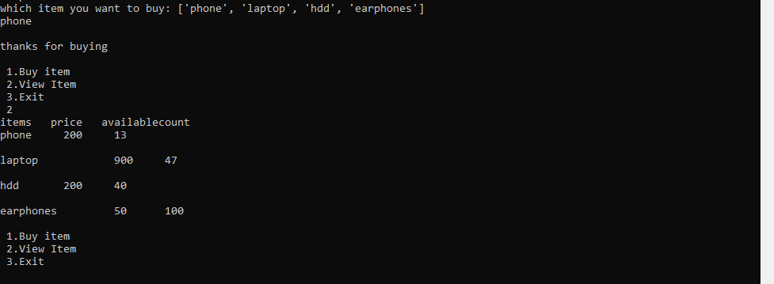

**CONCLUSION:**

The above project gives us a very brief knowledge and information of how the Inventory Management System works.

Thus we have successfully performed the project to create **Simple Inventory Management System** using Python program.